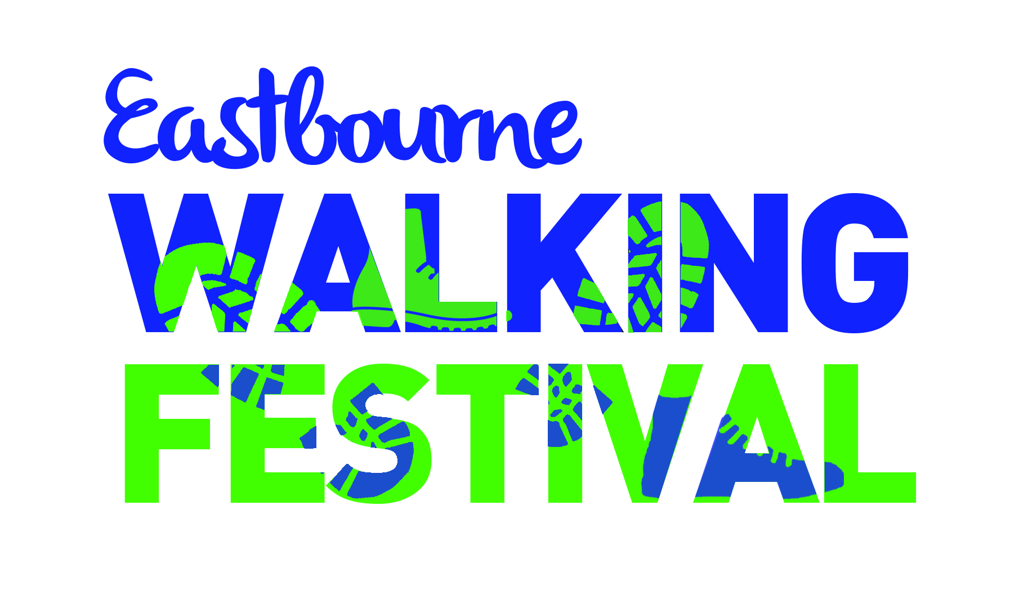

Walk Submission Form

We are aiming to offer a variety of walks each day of the festival. To achieve this we need walk leaders to offer alternative days for their walk if possible. We would also like to know if you are willing to offer your walk more than once. If you are only free to lead a walk on a particular day, please indicate this.

Your name/Organisation's name: ….......................................................

Leader's phone number: …......................................

Email address: ….................................................................................................................

Name of Walk: …............................................................................................

Possible dates of walk: …............................ …...............................
(give as many as possible)
….…....................... …...............................

Please identify your preferred date if you have one.

I can offer this walk more than once: Yes/No

Description of walk (include the highlights, terrain, hills, stiles):

…............................................................................................................................................

…............................................................................................................................................

…............................................................................................................................................

Approximate distance: …............................. Maximum no. of walkers: ….........
(which may need to change in the light of gov guidance)

Start time: …........................ Approximate finish time: …..............................

Exact meeting point (with post code or grid reference): …...................................................

Give details of public transport to/from meeting point: ….........................................................

…...............................................................................................................................................

Refreshments ie. flask/cafe/picnic?: …....................................................................................

Dogs welcome?: Yes/No Toilets ie. Start/finish/en route?: ……………………………..
Pushchair/Wheelchair friendly? Yes / No

Level of difficulty: Easy/Moderate/Challenging

